
General Manager (S & M - CM)
Sales & Marketing - Consumer Mobility
3rd Floor, New CTS Building
16, Greams Road, Chennai – 600 006

S&M-CM/165/RCVS & TOPUPS/2011-12 /32 Dated @ Chennai 6 the 19-10-11.
Sub: Diwali offer of Full Talk value for the Top-ups –reg
Ref: CO order no.26-18/2010-T&C-CM Circular No.63/11-12 dt 23-09-11

W.r.t the CO order under ref., approval of the competent authority is hereby conveyed for the full talk value offer for all Top-ups with MRP Rs.100/- to Rs.1100/- in C-TOP-UP and MRP Rs.110/- and above in Paper vouchers in 2G & 3G prepaid Mobile services in TN LSA (including Chennai Telecom District) from 21-10-11 to 31-10-11

The details are given below:-
The festival offer is | Full Talk Value equal to MRP**
Period of Offer | 21-10-11 to 31-10-11
Applicable for | -All TOP-UPs* in Paper Vouchers of Value of Rs.110/- and above.  -New set of TUs from MRP Rs.100 to Rs.1100 in C-TOP-UP
Other conditions | This offer is applicable for both Tamilnadu Circle and Chennai TD.

*All the existing unsold paper RCVs are converted into TUs ( as per the rationalization of tariff) and Full Talk time offer is available for these paper TUs of MRP Rs. 110/- and above also.
** Due to technical reasons in IN, for some denominations of TUs, full talk value will be 1 paisa less than MRP. (list is enclosed).

This is for kind information and necessary action please.

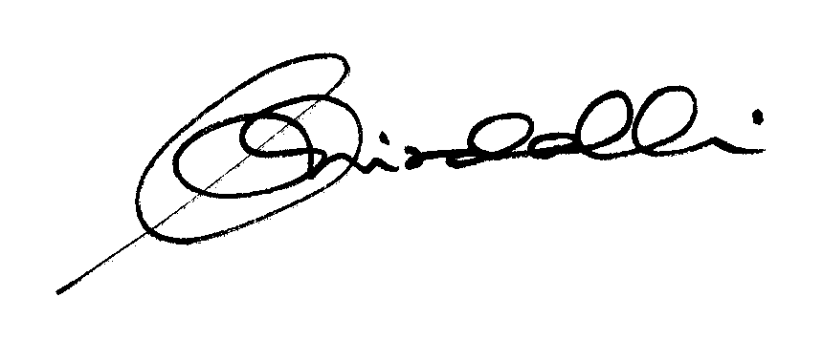

(KR. ARAVINDAVALLI)
AGM MKTG-CM, TN CIRCLE

To
GM (NW-O CM), Trichy -1/ Coimbatore – For information & necessary action please.
GM(S&M-CM), Chennai Telephoes, Chennai for information pl.
GM (F) / Sr. GM (TR) TN Circle, Chennai for information please.
DGM In charge IN - Trichy & Bangalore - for necessary action please.
DGM(NW-O)/DE Commercial, Coimbatore/ - For information & necessary action please.
ALL HEADS OF SSAs-- FOR KIND INFORMATION AND NECESSARY ACTION TO POPULARISE THE OFFER THROUGH PRESS BRIEF IN LOCAL NEWS PAPERS (WITHOUT INCURRING ANY EXTRA EXPENDITURE) PLEASE.

DGM (Sales) & AGM (Sales), Chennai-6 –For information and informing Sales Heads , franchisee managers and retail managers and other Channel partners along with commission structure as applicable.
DGM (CS), Chennai-6 - For information and informing Call Centre/Customer Service Centre Officials and ensure uploading the information on the website “tamilnadu.bsnl.co.in” .
DGM(S&M-CM)/AGM(S&M-CM), Chennai Telephones, Chennai – For information please.
MRP | Talkvalue | OfferTalkvalue
100 | 90.66 | 99.99
110 | 99.73 | 110
120 | 108.79 | 119.99
130 | 117.86 | 129.99
140 | 126.93 | 140
150 | 135.99 | 149.99
160 | 145.06 | 160
170 | 154.13 | 170
180 | 163.19 | 179.99
190 | 172.26 | 190
200 | 181.32 | 199.99
210 | 190.39 | 210
220 | 199.46 | 220
230 | 208.52 | 229.99
240 | 217.59 | 240
250 | 226.65 | 249.99
260 | 235.72 | 259.99
270 | 244.79 | 270
280 | 253.85 | 279.99
290 | 262.92 | 290
300 | 271.99 | 300
310 | 281.05 | 309.99
320 | 290.12 | 320
330 | 299.18 | 329.99
340 | 308.25 | 339.99
350 | 317.32 | 350
360 | 326.38 | 359.99
370 | 335.45 | 370
380 | 344.51 | 379.99
390 | 353.58 | 389.99
400 | 362.65 | 400
410 | 371.71 | 409.99
420 | 380.78 | 420
430 | 389.85 | 430
440 | 398.91 | 439.99
450 | 407.98 | 450
MRP | Talkvalue | OfferTalkvalue
460 | 417.04 | 459.99
470 | 426.11 | 469.99
480 | 435.18 | 480
490 | 444.24 | 489.99
500 | 453.31 | 500
510 | 462.38 | 510
520 | 471.44 | 519.99
530 | 480.51 | 530
540 | 489.57 | 539.99
550 | 498.64 | 549.99
560 | 507.71 | 560
570 | 516.77 | 569.99
580 | 525.84 | 580
590 | 534.9 | 589.99
600 | 543.97 | 599.99
610 | 553.04 | 610
620 | 562.1 | 619.99
630 | 571.17 | 630
640 | 580.24 | 640
650 | 589.3 | 649.99
660 | 598.37 | 660
670 | 607.43 | 669.99
680 | 616.5 | 679.99
690 | 625.57 | 690
700 | 634.63 | 699.99
710 | 643.7 | 710
720 | 652.77 | 720
730 | 661.83 | 729.99
740 | 670.9 | 740
750 | 679.96 | 749.99
760 | 689.03 | 760
770 | 698.1 | 770
780 | 707.16 | 779.99
790 | 716.23 | 790
800 | 725.29 | 799.99
810 | 734.36 | 809.99
MRP | Talkvalue | OfferTalkvalue
820 | 743.43 | 820
830 | 752.49 | 829.99
840 | 761.56 | 840
850 | 770.63 | 850
860 | 779.69 | 859.99
870 | 788.76 | 870
880 | 797.82 | 879.99
890 | 806.89 | 889.99
900 | 815.96 | 900
910 | 825.02 | 909.99
920 | 834.09 | 920
930 | 843.16 | 930
940 | 852.22 | 939.99
950 | 861.29 | 950
960 | 870.35 | 959.99
970 | 879.42 | 970
980 | 888.49 | 980
990 | 897.55 | 989.99
1000 | 906.62 | 1000
1010 | 915.68 | 1009.99
1020 | 924.75 | 1019.99
1030 | 933.82 | 1030
1040 | 942.88 | 1039.99
1050 | 951.95 | 1050
1060 | 961.02 | 1060
1070 | 970.08 | 1069.99
1080 | 979.15 | 1080
1090 | 988.21 | 1089.99
MRP | Talkvalue | OfferTalkvalue
1100 | 1050 | 1100

